|  |
| --- |
|  |
| **Mentor Messenger**  September 2017 |
|  |
|  |
| Every child deserves a champion – an adult who will never give up on them, who understands the power of connection and insists that they become the best that they can possibly be.  **-Rita Pierson** |
|  |

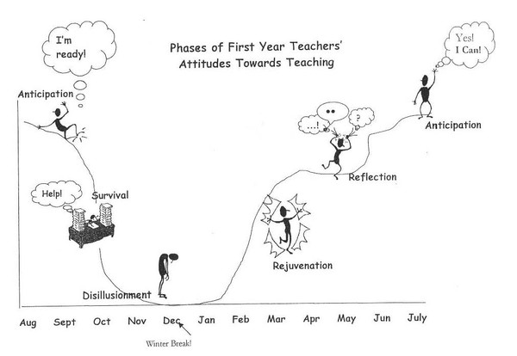**The Survival Phase!**



|  |
| --- |
|  |
| During the second month… -Take grades on student work and post them in Infinite Campus.  -Align your lessons to the Nevada Academic Content Standards.  -Collect AIMSWeb data for your Tier 2 and 3 students.  -Send out a Conference Sign-Up sheet for Conference Week.  -Most Importantly: Celebrate the wonderful things going on in your classroom! School specific things to know… -What meetings do you need to attend and what teams are you on?  -What are your expectations for Open House night?  -Do you know what to do in case of a Code Red, Code Blue, Code Yellow, or fire drill? |

***Why include this?*** *The first year of teaching may feel like a roller coaster for many new teachers. Recognizing the phases of first year teaching can help you to reflect upon your experience and understand that you are not alone.*

**The Survival Phase:** The first month of school is very overwhelming for new teachers. They are learning many concepts at a rapid pace. During the survival phase, most new teachers struggle to keep their heads above water. They become very focused and consumed with the day-to-day routines of teaching. There is little time to stop and reflect on their experiences. It is not uncommon for new teachers to spend up to seventy hours a week on schoolwork. New teachers, still uncertain of what really works, must develop their lessons for the first time. Although tired and surprised by the amount of work, first-year teachers usually maintain a tremendous amount of energy and commitment during this phase.

**Calming the Chaos- Continuing to Establishing Procedures and Expectations**

Structure and procedures are vital parts of classroom management. Every part of the day needs to be thought through and brought into alignment with what works best for your teaching style, your students’ personalities, the age group and any special challenges that could cause a distraction.

Take Time To Reflect On These Procedures:

* Entering/Leaving the classroom
* Posting your objectives/daily schedule
* Quiet Signal
* Listening/Responding to class discussions (accountable talk)
* When kids need a pencil or piece of paper

Think about what you do for each of these procedures. Do the students understand the expectations? If not, continue to discuss the procedures as a class, make posters and/or act out what should be seen or heard in these situations. If you need some help, ask your CT for support.

***Take A Minute and Check It Out:***

**Induction and Mentoring WCSD Page:**  [**https://www.washoeschools.net/Page/510**](https://www.washoeschools.net/Page/510)

**Use a QR Code:**

**Mentoring and Induction Website**



***It’s That Time! Have You Signed Up For Classes?***

**My PGS Registration**



**Join us on Pinterest at: WCSD Mentoring Program**

[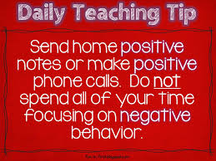](http://www.google.com/imgres?imgurl=http://2.bp.blogspot.com/-d7_ybIpuLlU/UbCEergZyPI/AAAAAAAAGlo/SaCZzm1CDGk/s1600/Slide2.JPG&imgrefurl=http://fun-in-first.blogspot.com/2013/06/daily-teaching-tips-and-spelling.html&h=720&w=960&tbnid=Coz6ajtLPU334M:&docid=uXjqj5j0t1N9UM&ei=pITeVcDSK42sogTCjZqwDQ&tbm=isch&ved=0CC0QMygQMBBqFQoTCMC06dupyMcCFQ2WiAodwoYG1g)